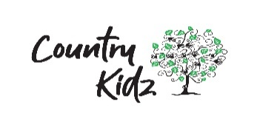
First Aid Certification Policy

Rationale
To ensure all practical steps are taken to provide all kaiako with First Aid certification to effectively manage accidents and injuries should they occur at Country Kidz.
Objective
To ensure all kaiako are provided with the opportunity to gain professional development in first aid and obtain New Zealand Qualification Authority accreditation. This enables all Country Kidz kaiako to carry out basic first aid for the wellbeing of all participating in our learning environment.

Policy
Our Centre endeavours to provide an environment in which children’s wellbeing is promoted and they are kept safe and healthy. At times tamariki may require first aid attention and ensuring all kaiako have certified first aid training enables to further provide for this. For all childhood education services, an adult must be present at all times for every 25 tamariki attending (or part thereof). If tamariki are injured, any required first aid will be administered immediately by a permanent staff member of Country Kidz.
Kaiako will be given the opportunity to participate in accredited first aid courses at a time that works for the learning environment and themselves. Training will be paid for the duration of the course.
Country Kidz will pay for all kaiako to obtain New Zealand Qualification Authority accredited training (6400, 6401, and 6402) as part of their remuneration package. Should kaiako leave within one year of completing the training, reimbursement for the full cost of the first aid course must be paid back to Country Kidz.
Refresher first aid course opportunities will be provided to all kaiako and must be completed within four months of their first aid renewal date otherwise kaiako must pay for the comprehensive course less the cost of the refresher course.

Aligns with:
Licensing criteria for centre-based ECE services 2008 (amended, September 2022)
Education (early Childhood Centres) Regulations 2008
Country Kidz Health and Safety System
Country Kidz Child Health Policy
Country Kidz Illnesses, Injuries, and Incidents Policy
Country Kidz Strategic Plan 2022-25
Our code, our standards – Code of professional responsibility and standards for the Teaching Profession

Review
Review when there is a significant change to legislature or as part of the annual management plan.
Authorised:
Date: | April, 2025
Next Review: | Add to Annual Management Plan for May, 2026 notwithstanding a change in legislation or criteria

